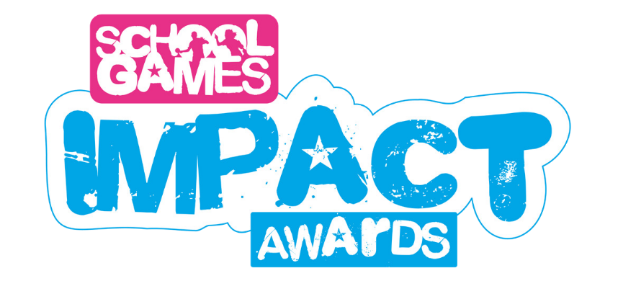

ENTRY FORM 2023/24

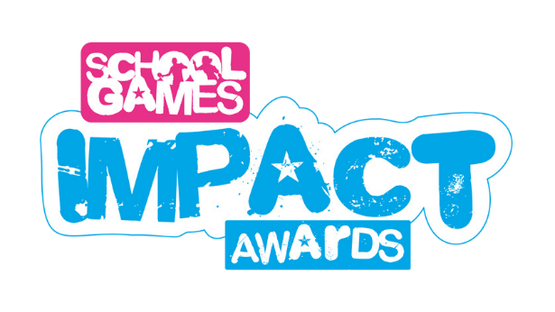

Thank you for downloading the entry form for the School Games Impact Awards!
You can enter the School Games Impact Awards if you are either an SGO, part of an Active Partnership, an NGB, or a school.
All you need to do is fill out the form below and submit within the submission window relevant to the current term.
For the 2023/24 academic year, these are the windows:
- Autumn Term: 22nd December 2023
- Spring Term: 22nd March 2024
- Summer Term: 31st July 2024
The work in your entry must correspond to the term to which you are submitting. Please fill out this form in response to the prompt questions.
Feel free to attach any relevant photos or videos with your submission providing you have permission to share them, especially if they are of young people.
Above all else, the important thing to show in your entry is the IMPACT your work had on young people.
Further information on the Impact Awards, including the category criteria, can be found here.
When complete, send this document and any other relevant content to
Info@yourschoolgames.com.
Remember: for SGO colleagues, each submission to the School Games Impact
Awards is considered as a case study and therefore contributes to your School Games
expectation to submit one case study per academic year. SGOs can submit their case
study via the dashboard and select the option to enter it as an Impact Award.
We can’t wait to see your entry!

General Information
Name
Term in which your impact took place
Area
Please indicate whether you are an SGO, or submitting as an Active Partnership, NGB or a school

Context
Background Information
What was the aim of the work?
Which School Games outcome did it focus on?
Which Impact Awards category are you entering?

(See here for the list of categories)

Intent
What motivated and drove it to happen?
How was the issue / need identified?

Consider the evidence of need videos for support.

Target Group
Who was involved?
(e.g. year groups, schools, demographics, key individuals?)

Context
What activities were delivered?
Who delivered the activities?
Where and when did they happen?
What were the timescales?
What partners did you work with if any?

Impact
Who was engaged / who did the work reach?
Who was impacted?
Was there a young person who had a substantial positive result from participating in the project? Can you provide a description of their journey pre, during and post the project.
What wider benefits did you observe as a result of your work?

For example: increased attainment, positive shift in whole school culture, increase behaviour etc.

Challenges
Reflect on the work and consider what challenges were experienced and how were they overcome?

Sustainability
How can the work become more sustainable?
What are the next steps?
If you worked with any partners / community organisations, how do you plan to continue to develop this partnership?

Top Tips
As a result of your experience, what are your three top tips for those looking to replicate this project?
What was your biggest learning from the work?

