Case Study
Intent: This project grew and changed over the years to accommodate the parent and pupil voice.
The Journey:
- Listening campaign on barriers and concerns with parents. Key issues raised: SEND provision and concerns transitioning from primary to secondary.
- Key SEND pupils/ low confidence pupils identified from both settings host site and biggest feeder school
- Objectives: year 6’s make friends with year 7’s. Session content - sensory circuits to support regulating emotions, boosting confidence of coming to Regis and familiarising themselves with the facility.

The listening campaign was our first step. We interviewed 50 parents who were identified in multiple of the following categories: siblings across both sites, SEND, pupil premium and EAL. The interview was more personal, it was a neutral setting to ensure parental engagement, no survey or note taking. Simple questions around community and campus strengths and areas for improvement. The information was collated to map out what the focus areas could be and how the campus and School Games work could support. The two key areas identified by the parents were:
- Not enough support for SEND pupils
- Children struggling going from primary to secondary school.

Implementation:
Once this pre- work was achieved the SGO liaised with the SEND leads of both sites to discuss a project aiding transition for the most vulnerable/low in confidence SEND pupils. Research was done around a philosophy of “sensory circuits”. This looks at supporting pupils handling their emotions through different physical activity types: Alerting (lots of physical movement), calming (Yoga, stretching) and organising (thinking activities e.g. boccia). A programme was developed for this.
The pupils came together once a week during lunchtimes to participate in the club, changing partners to increase friendship groups and confidence. Each session had a focus, and they were asked on the last session how they felt learning when going back to school. Each pupil had different needs and were able to articulate which was best for them for their mindset in the classroom.
The impact:
The programme has now been so successful that it is embedded into the annual calendar and is a valued, essential part of these pupils’ transition, taking place before the standard school transition days. This gives them a head start and confidence with transition.
As the programme has developed, it has strengthened relationships between the schools’ inclusion departments enhancing the collaboration and knowledge of the pupils.
Staff
What impact has the SEND transition club had the pupils?
TRS: “It was interesting to see the sensory circuits help children regulate their emotions”
Southway:
“The children developed new friendships which helped ease the anxiety from transitioning between primary and secondary.” “Children were able to talk openly about their feelings and even suggest ways they could regulate themselves, either by burning off excess energy or having mini sensory breaks.”

What School professional benefits has there been?
TRS: “It was great to meet the Southway TA’s and have a ‘hand over’ of students.”
Southway: “It has been vital to build relationships with the TRS staff, We are now able to pass on information that might not necessarily come across the right way via emails etc. To have open face to face conversations has really allowed us to express and discuss the needs of the children.”

Have you noticed any changes with the children following the club?
Southway: “With the club being after lunch, lunchtime is sometimes a worrying experience for our children, when lunchtime is over, we have found that our children find it very difficult to regulate themselves and prepare for the upcoming lessons. Due to the club running after lunch, our children have come back regulated, calm, and ready to face the afternoon relaxed.”

Is there anything you would change?
TRS: “I think if I was to change anything I would make the course slightly shorter to avoid exam time and therefore avoid disruption.”
Southway: “Possibly trialling a morning session before registration. Again, this is another time where our children would benefit from the club.”

Anything else you would add?
TRS: “I would like this to be a yearly thing so it could be used in inclusion as a whole, I will be talking to inclusion staff about the ‘sensory circuits’ idea early next year.”
Southway:
“The positive impact it’s had on all our children they have blossomed over each session, the children are very excited, and look forward to each session. Their confidence which they have developed over these sessions is now feeding into their wider school life.”

Pupil feedback (Wyatt primary school):
-Have you enjoyed the club?
“Definitely, I loved it and want to do it again even though I am in year 8. I loved the space and activities we did”
-How has the club helped you?
It has helped my confidence both before starting Regis and in my second year in club. Helping in a leadership role, it helped my leadership skills.
-Has anything specific improved?
The alerting activities helped me have a louder voice when needed
-Anything else you want to say?
I did new age kurling for the first time at the club, then represented the school at new age kurling!
Pupil thoughts:
What order of the activity type would you do and why?
Izzy: “Boxing & speed bounce then football table then Yoga. I have a lot of energy to burn off.”
Katelyn: “ I would do physical activities and then YOGA because then I’m in the right mindset because I’m calm and relaxed”
Tiffany: “I would do this again because it was fun”
Emillia “I learned YOGA, it has helped me calm down and my brain better to concentrate”

Pupil feedback word cloud:
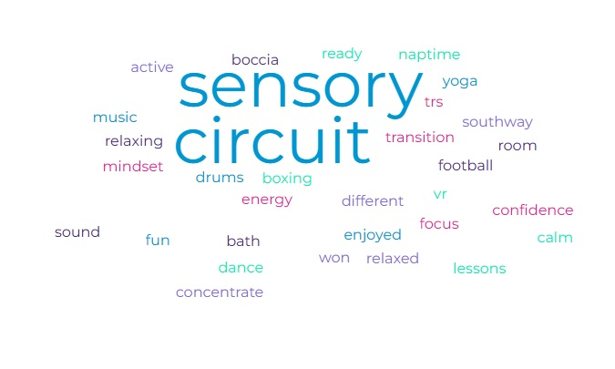

SGO reflection:
I have been proud of this project as it has clearly positively impacted on the pupils. Wyatt was one key pupil I focused on and asked questions of. Personally see his confidence grow weekly was inspiring. He enjoyed the environment so much that he joined the boxing club. The TRS team were able to understand his needs much earlier and build a relationship with him, aiding his transition to the secondary school. The programme success led to Wyatt coming back the following year as a secondary pupil to participate again but support the year 6s in the club and their transitional journey into secondary school. This leadership role was so important to him and has helped his confidence around school.
Successful key outcomes:
- Individual pupil stories- confidence building and even aiding leadership
- Enhanced staff relationships, supporting transition
- Evidence via pupils’ feedback of feeling more confident going to secondary school
- Individual sensory circuit created to support emotional handling and understanding of themselves
Sustainability:
- This is now built into the transition programme
- Relationships between the primary and secondary SEND departments I
- Heads of years are involved knowing the benefits
- Pupil and teacher voice taken to add activities

Challenges:
- Finding the ideal time
- Getting SLT on board to release teaching assistants

Top Tips:
- Involving SEND leads
- Experiment activities to find the best ones for each category of activity type
- Evidence feedback
- Use external provider to broaden the experience

