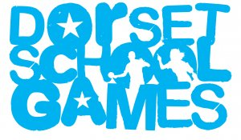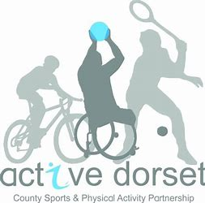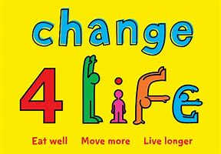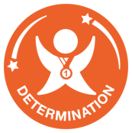
Can you complete the activities below?
Try one a day, or 4 a day. Want to share a video of you doing the challenge. Tweet to @dorsetgames
Monday | Tuesday | Wednesday | Thursday | Friday | Saturday | Sunday
Sock keep-ups | Standing Long jump  Can you jump your own height? | Sock Juggling | Plank Challenge | Speed Bounce | Sock keep-ups pairs | Target sock golf
Monday | Tuesday | Wednesday | Thursday | Friday | Saturday | Sunday
Obstacle course | Sock hand tennis keep ups | Cha Cha Slide  dance | Skipping | Standing triple jump | Blindfolded  Balance on 1 leg | Musical statues
Monday | Tuesday | Wednesday | Thursday | Friday | Saturday | Sunday
Stair speed climb  (Up only) | Learn 5 Fortnite dances | Crab football | Jog to Happy by Pharrell Williams  Burpee Every Happy | Agility  Run challenge | Press up position hold challenge | V-sit hold  challenge
Monday | Tuesday | Wednesday | Thursday | Friday | Saturday | Sunday
Blindfold Obstacle  challenge | Press up position hold | Wall Sit challenge | Football dribble shuttle runs | Sock Cricket bowl into a target | Pairs sock juggling | Learn the Haka dance or make up your own

