Activity Sheet Four : let’s think about some numeracy activities this week!
Try these fun activities with your family. Having fun whilst being active is very important. You can compete with yourself & each other if you want to, but enjoying the activities is the main thing.
Perhaps you could record yourselves doing the activities & share the clips with your friends & family if your parents/carers are happy for you to do so?
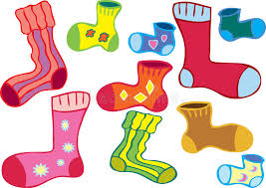
Safety- try to move anything that you could break or trip over out of the way. Make sure your shoe laces are tied up & you have a drink ready.

Matching Socks Challenge : You will need lots of socks & a box/bin
Activity a) mix up lots of single socks & place them randomly all over a table.
“Ready, steady go!”- match them up into pairs as quickly as you can. You could time yourself & compete against yourself &/or other members of your household.
Activity b) mix up lots of single socks & place them randomly all around a room
“Ready, steady go!”- match them up into pairs as quickly as you can. You could time yourself & compete against yourself &/or other members of your household.
Activity c) mix up your single socks
Place a box or a bin somewhere in the room.
“Ready, steady go!”- match them up into pairs as quickly as you can. Wherever you match a pair, roll them up into a ball & aim for the box or bin. How many get you get in the box/bin first time? Try to beat your score.
How to make this activity harder :
- Use more socks. Different sizes.
- Move the box/bin further away
-Travel to the socks in different ways eg: jump, hop

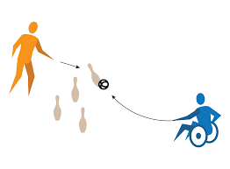
Knock Down Challenge : You will need rolled up socks & empty bottles & boxes
*Place all the bottles & boxes on the ground in a room or in the garden
*Decide on a ‘throwing’ line. Put all the rolled up socks behind the ‘throw’ line
*From behind the ‘throw’ line how many bottles/boxes can you hit & knock over with your sock balls? Can you beat your score? Can you beat someone else’s score?
How to make this activity harder :
-Put the ‘throw’ line further away
-Take it in turns with a family member. If you knock an item over, collect it. When all the items have been knocked over & collected, count them. Who has the most?
-Put different numbers or values on each item. Add them up as you knock them down. What’s your final score?

