Healthy Fit Family Challenge
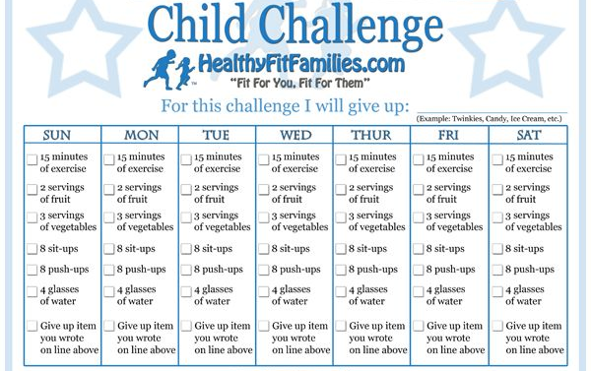
Children and young people should aim to be physically active for an average of at least 60 minutes of moderate intensity exercise per day.

