Activity Sheet One : there will be two new activities every week whilst you are at home.
Try these fun activities with your family. Having fun whilst being active is very important. You can challenge yourself & each other if you want to, but enjoying the activities is the main thing.
Perhaps you could record yourselves doing the activities & share the clips with your friends & family if your parents/carers are happy for you to do so?
Safety- try to move anything that you could break or trip over out of the way. Make sure your shoe laces are tied up & you have a drink ready.

Star Jump Challenge : In pairs (you perform, whilst the other person rests & cheers you on! Then you swap) Try to do this to music &/or in the garden if possible
15secs
30secs
45secs
1min
If star-jumps are a bit tricky you could just jump or run/march on the spot. If you are a wheelchair user you could try to move your arms out, your legs up, whatever you can do you should try to do.

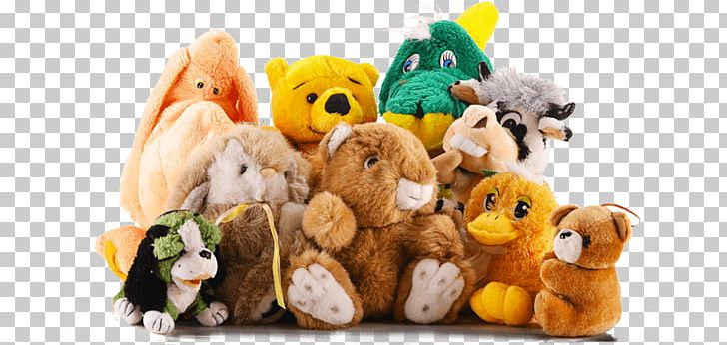
Cuddly Toy Challenge : Collect as many cuddly toys together as you can find.
Put all the toys in a bin or box at one end of the room/garden.
Put an empty bin or box as far away as possible. This could be upstairs.
Take one toy at a time & place it in the empty box. You can do this as a relay if the box is a long way away or you are tired.
You can time yourself against yourself or others if you want to.
To make it harder you could think of different ways of taking the toy eg-under your armpit/between your knees/throwing it up & down if you are outside. Or you could travel differently eg hop/jump/backwards.

