Activity Sheet Seven : This week we will be trying two different types of circuit challenges : fitness & skills.
Take some photos to show your friends & family how well you are doing & what fun you are having being active.
Safety- try to move anything that you could break or trip over out of the way. Make sure your shoe laces are tied up & you have a drink ready.
These circuits could be completed with some high energy music to help motivate you

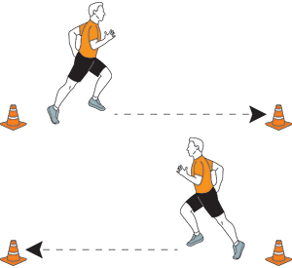
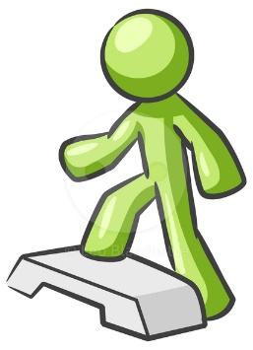
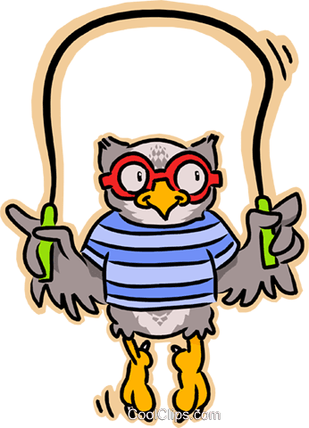
Fitness Circuit : You will need something to mark a space with eg: a cushion (indoors) a garden plant pot (outdoors), a rope & access to a step or stairs
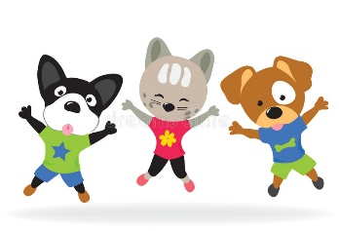

Complete this circuit 2-3 times. Count them if you want to or ask someone else to keep score.
1) Shuttles : put your markers as far away as you want to. Move backwards & forwards between the markers as many times as you can in 1 minute.
2) Skipping : put the rope over your head & step or jump over it as many times as you can in 1 minute. If you are a wheelchair user ask two family members to lift the rope over your head for you to wheel across.
3) Star Jumps : complete as many star jumps as you can in 1 minute. If a star shape is a bit tricky see how high you can jump. If you are a wheelchair user move your arms & legs as much as you can as many times as you can in a way that you can.
4) Step Ups : Step up onto a step or stair one foot at a time. Step back down one foot at a time. Try not to jump up or down. If you are a wheelchair user or find balancing on one leg a bit tricky sit down & alternate lifting your legs up & down as many times as you can in 1 minute.
5) Your own idea : Can you think of an exercise you could do for 1 minute?
Skills Circuit : you will need a cuddly toy or a ball, a box or a bucket, lots of pairs of rolled up socks.
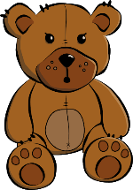
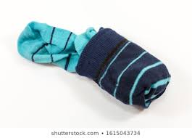

Complete this circuit 2-3 times. Count them if you want to or ask someone else to keep score. You might want to practice the skills a bit first.
1) Hold the teddy or ball with two hands. Throw the teddy or ball in the air just above your head & catch it as many times as you can in 1 minute. If you drop it don’t worry, just pick it up & keep going.
How to make this harder-
- Use a smaller teddy or ball
- Use one hand
- Use your less dominant hand (the hand you don’t write or wave with)
2) Pass the teddy or ball around your tummy as many times as you can in 1 minute
How to make this harder-
- Pass the teddy/ball the opposite way
- Pass it 5 times one way & then 5 times the opposite way & repeat for 1 minute
- Use a bigger teddy or ball
3) Place all the rolled up socks in a pile. Put the bucket or box away from the pile of socks. Try to throw as many balls of socks as you can into the bucket .When you have thrown them all, retrieve them & start again. Keep trying for 1 minute.
4) Put two balls of socks opposite each other as far away as you can. These are your floor markers. Use either your feet or your hands to dribble a ball/cuddly toy from one marker to the other as many times as you can in 1 minute. If you are a wheelchair user find something to push the ball/cuddly to with.
How to make this harder-
- Create a slalom using more pairs of socks as markers. Move in & out.
- Use a smaller ball/cuddly toy
- Use an umbrella or a rolling pin to dribble the ball/cuddly toy
5) Your own idea : Can you think of a skill you could do for 1 min?

