Activity Sheet Nine : This week our activity is inspired by a traditional board game.
Take some photos to show your friends & family how well you are doing & what fun you are having being active.
Safety- try to move anything that you could break or trip over out of the way. Make sure your shoe laces are tied up & you have a drink read
ACTIVITY : SNAKES AND LADDERS : Ladder = climb up Snake = slide down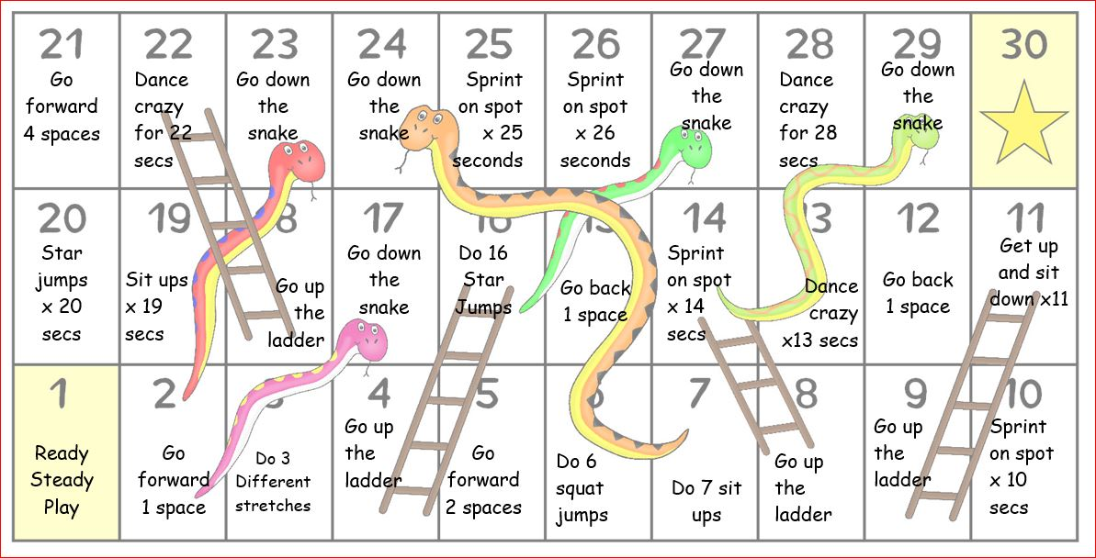
- What different movements/tasks could you do if you find some of the challenges a bit tricky or a bit easy?
- Think of some alternative movements/tasks & put them into the game
- Remember each player could have different movements so that everyone can play together
- Could you add some equipment to the movements/tasks or make them partner tasks & play in pairs?

