**FITNESS FUN – PERSONAL CHALLENGE**

**WEEK 3, CHALLENGE 3- BETTER BALANCE**

**25/01/21 – 29/01/21**

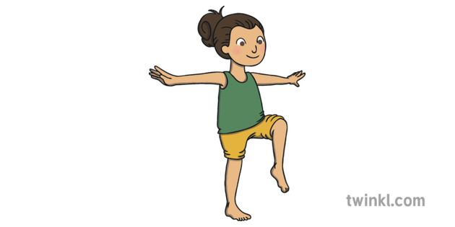****

**Exercise 3: Better Balance**

How many times can you catch the ball?

* Stand on one leg with the other off the ground at 90◦
* Balance a pair of rolled up socks on the raised leg
* Whilst balancing on one leg, throw a large ball against a wall
* Without dropping the socks, or the ball, how many catches

Can you do?

* If you drop the sock or the ball, that one doesn’t count, but you

Can continue trying until your time runs out.

Each successful catch is equal to one point

-**How many can you do in 30 seconds?**

|  |  |  |  |
| --- | --- | --- | --- |
| Challenge Points | | | |
| Catches | Points | Catches | Points |
| 1-5 | 1 | 14-15 | 6 |
| 6-7 | 2 | 16-17 | 7 |
| 8-9 | 3 | 18-19 | 8 |
| 10-11 | 4 | 20-24 | 9 |
| 12-13 | 5 | 25+ | 10 |