PRIMARY & SECONDARY 60 SECOND SCREEN BREAK ACTIVITIES
Ensure you take regular breaks from your screen – try out these activities – record your attempts on the Tracking Sheet - can you beat your own scores?
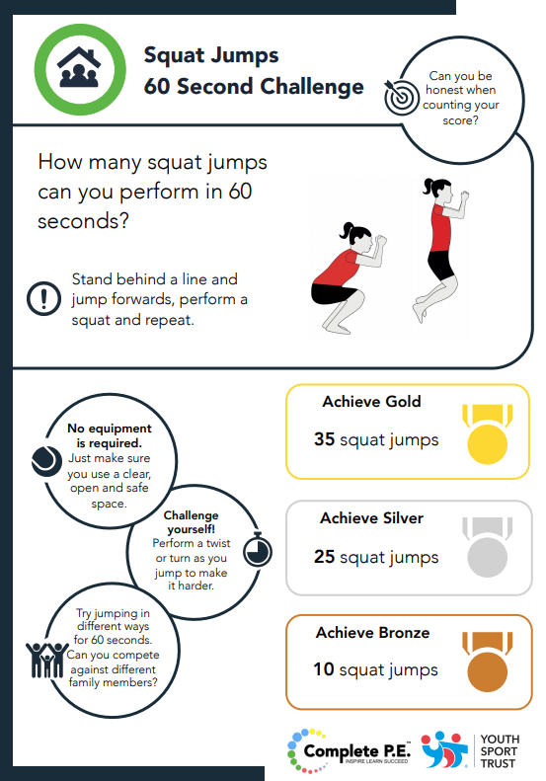
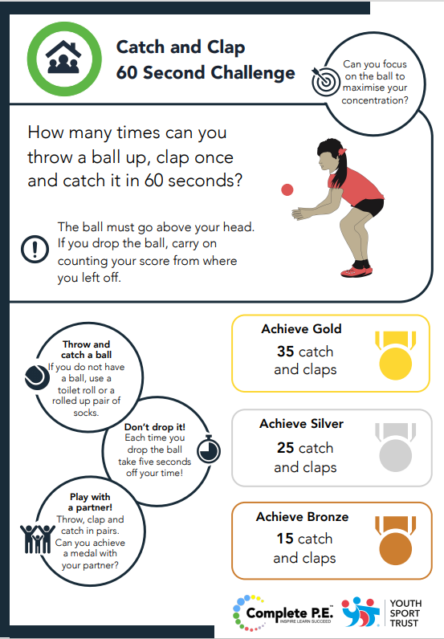
Week 3

Contact: Angela Daniel
a.daniel@grange.outwood.com
Twitter @SGOOutwood
www.yourschoolgames.com/sgo/outwwood-grange

